Create Question Test Requirements

Input Space Partitions

1. Input variables:

6 input boxes: Question text, possible points, starting points, answer text, answer points

1 check box: Random order

1 drop down: Question type

2 buttons: Add question, Finish, clear answer, add answer

2. Definition of characteristics of input variables:

char 1: text box is empty or not

char 2: possible points, starting points, and answer points are numbers or not

char 3: possible points, starting points, and answer points to 0

char 4: check box is selected

char 5: multiple choice, short answer, choose all

char 6: form button is clicked

3. Partitions:

char 1: [empty, not empty]

char 2: [number, not number]

char 3: [neg, 0, pos]

char 4: [selected, not selected]

char 5: [multiple choice, short answer, choose all]

char 6: [add question, finish, clear answer, add answer]

4. Completeness and disjointness:

It is complete but not disjoint

5. Values:

char 1: ["", "a" ]

char 2: [1,a]

char 3: [-1, 0, 1]

char 4: [selected, not selected]

char 5: [multiple choice, short answer, choose all]

char 6: [add question, finish, clear answer, add answer]

6. Test requirements that satisfies Base Choice coverage:

Base tr:

tr 1: ["a", 1, 1, selected, multiple choice, add question]

Base coverage:

tr 2: ["a", 1, 1, selected, multiple choice, finish]

tr 3: ["a", 1, 1, selected, multiple choice, clear answer]

tr 4: ["a", 1, 1, selected, multiple choice, add answer]

tr 5: ["a", 1, 1, selected, short answer, add question]

tr 6: ["a", 1, 1, selected, choose all, add question]

tr 7: ["a", 1, 1, not selected, multiple choice, add question]

tr 8: ["a", 0, 0, selected, multiple choice, add question]

tr 9: ["a", -1, -1, selected, multiple choice, add question]

tr 10: ["a", a, a, selected, multiple choice, add question]

tr 11: ["", 1, 1, selected, multiple choice, add question]

7. Test set:

tr 1: "a", 1, 1, selected, multiple choice, "a", 1, add question

Expected output: created question shows up in quiz preview

tr 2: "a", 1, 1, selected, multiple choice, "a", 1, finish

Expected output: move to "Edit question" page

tr 3: "a", 1, 1, selected, multiple choice, "a", 1, clear answers

Expected output: text field of answer goes blank

tr 4: ["a", 1, 1, selected, multiple choice, "a", 1, add answer]

Expected output: a new answer appears

tr 5: ["a", 1, 1, selected, short answer, "a", 1, add question]

Expected output: same behavior as base case

tr 6: ["a", 1, 1, selected, choose all, "a", 1, add question]

Expected output: same behavior as base case

tr 7: ["a", 1, 1, not selected, multiple choice, "a", 1, add question]

Expected output: same behavior as base case

tr 8: ["a", 0, 0, selected, multiple choice, "a", 0, add question]

Expected output: same behavior as base case

tr 9: ["a", -1, -1, selected, multiple choice, "a", -1, add question]

Expected output: error message "invalid value"

tr 10: ["a", a, a, selected, multiple choice, "a", a, add question]

Expected output: error message "invalid value"

tr 11: ["", 1, 1, selected, multiple choice, "a", 1, add question]

Expected output: error message "Please enter question text"

8. Additional tests

An additional test was created to make sure that the correct page shows up with the given url.

**Test Results:**

All the test cases pass except for test case 9 (see Fig. CQ1)because the create_question page doesn't meet the requirement. If a negative value is input into any of the points input fields, the page should not add the question since this is an invalid input. Instead the page creates the question and assigns negative values to the points both for total possible points, starting points, and answer points. All other feature meet the requirements and so all other tests pass.

Fig. CQ1: All tests pass except for test 9

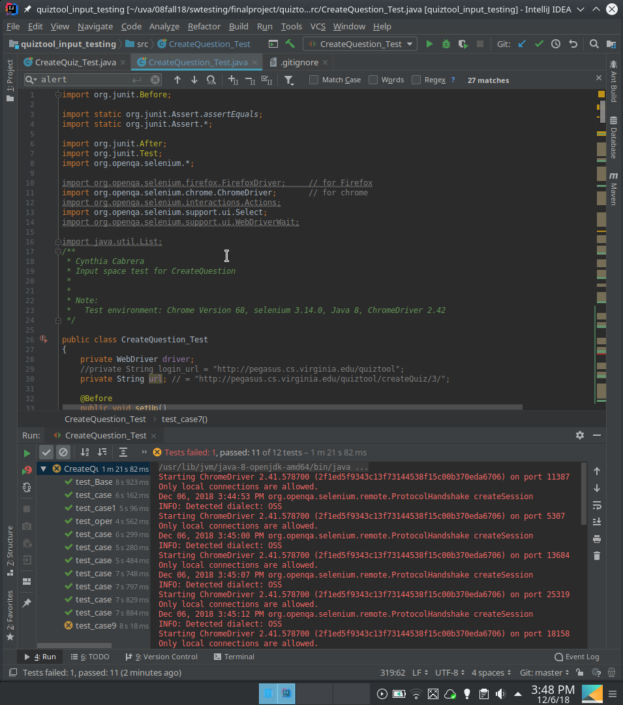

Automated Tests on Selenium

import org.junit.Before;

import static org.junit.Assert.*assertEquals*;

import static org.junit.Assert.*;

import org.junit.After;

import org.junit.Test;

import org.openqa.selenium.*;

import org.openqa.selenium.firefox.FirefoxDriver; // for Firefox

import org.openqa.selenium.chrome.ChromeDriver; // for chrome

import org.openqa.selenium.interactions.Actions;

import org.openqa.selenium.support.ui.Select;

import org.openqa.selenium.support.ui.WebDriverWait;

import java.util.List;

*/\*\**

*\* Cynthia Cabrera*

*\* Input space test for CreateQuestion*

*\**

*\**

*\* Note:*

*\* Test environment: Chrome Version 68, selenium 3.14.0, Java 8, ChromeDriver 2.42*

*\*/*

public class CreateQuestion_Test

{

private WebDriver driver;

//private String login_url = "http://pegasus.cs.virginia.edu/quiztool";

private String url; // = "http://pegasus.cs.virginia.edu/quiztool/createQuiz/3/";

@Before

public void setUp()

{

driver = new ChromeDriver(); // create an instance of the web browser and open it

System.*setProperty*("webdriver.chrome.driver", "/usr/bin/chromedriver");

//Login into quiztool app

url = "http://pegasus.cs.virginia.edu/quiztool/login";

driver.get(url); // open the given url

driver.findElement(By.*name*("username")).sendKeys("professorM");

driver.findElement(By.*name*("password")).sendKeys("swtesting1");

WebElement element = driver.findElement(By.*xpath*("(/html/body/div/div/form/div/button[@type='submit'])[1]"));

element.click();

// Go to createQuiz

url = "http://pegasus.cs.virginia.edu/quiztool/create_additional_questions/126/16";

driver.get(url); // open the given url

}

@After

public void teardown()

{

// Delete question if there is a question available to delete

try {

try { Thread.*sleep*(1000); } catch (InterruptedException e) { }

driver.findElement(By.*linkText*("Delete")).click();

try { Thread.*sleep*(1000); } catch (InterruptedException e) { }

driver.switchTo().alert().accept();

try { Thread.*sleep*(1000); } catch (InterruptedException e) { }

} catch (NoSuchElementException e) { }

driver.quit(); // close the browser

}

@Test

public void test_openURL()

{

*assertTrue*(driver.getPageSource().contains("Add Questions")); // check if we are on the right page

}

@Test

public void test_Base() // test case #1

{

// Fill input fields

driver.findElement(By.*name*("question_text")).clear();

driver.findElement(By.*name*("question_text")).sendKeys("a");

driver.findElement(By.*name*("question_points")).clear();

driver.findElement(By.*name*("question_points")).sendKeys("1");

driver.findElement(By.*name*("question_starting_points")).clear();

driver.findElement(By.*name*("question_starting_points")).sendKeys("1");

// Checkbox

if ( !driver.findElement(By.*name*("randomize_answers")).isSelected() )

{

driver.findElement(By.*name*("randomize_answers")).click();

}

// Dropdown

Select dropdown = new Select(driver.findElement(By.*name*("question_type")));

dropdown.selectByVisibleText("Multiple Choice");

// Fill input fields

driver.findElement(By.*name*("answer_0")).clear();

driver.findElement(By.*name*("answer_0")).sendKeys("a");

driver.findElement(By.*name*("answer_weight_0")).clear();

driver.findElement(By.*name*("answer_weight_0")).sendKeys("1");

// Click background to make sure all java scripts finish running

driver.findElement(By.*cssSelector*("body")).click(); // Click on the background to deselect the input field

// Submit (Add question)

WebElement element = driver.findElement(By.*xpath*("(/html/body/div[1]/div/div[2]/form/div[2]/button[@type='submit'])[1]"));

element.click();

// Accept alert popup

driver.switchTo().alert().accept();

// Check result (Stays in same page, and new question is displayed on quiz preview)

*assertTrue*(driver.getPageSource().contains("Q: a"));

}

@Test

public void test_case2()

{

// Fill input fields

driver.findElement(By.*name*("question_text")).clear();

driver.findElement(By.*name*("question_text")).sendKeys("a");

driver.findElement(By.*name*("question_points")).clear();

driver.findElement(By.*name*("question_points")).sendKeys("1");

driver.findElement(By.*name*("question_starting_points")).clear();

driver.findElement(By.*name*("question_starting_points")).sendKeys("1");

// Checkbox

if ( !driver.findElement(By.*name*("randomize_answers")).isSelected() )

{

driver.findElement(By.*name*("randomize_answers")).click();

}

// Dropdown

Select dropdown = new Select(driver.findElement(By.*name*("question_type")));

dropdown.selectByVisibleText("Multiple Choice");

// Fill input fields

driver.findElement(By.*name*("answer_0")).clear();

driver.findElement(By.*name*("answer_0")).sendKeys("a");

driver.findElement(By.*name*("answer_weight_0")).clear();

driver.findElement(By.*name*("answer_weight_0")).sendKeys("1");

// Click background to make sure all java scripts finish running

driver.findElement(By.*cssSelector*("body")).click(); // Click on the background to deselect the input field

// Submit (Finish)

driver.findElement(By.*linkText*("Finish adding Questions")).click();

//WebElement element = driver.findElement(By.xpath("(/html/body/div[1]/div/div[2]/form/div[2]/button[@type='submit'])[1]"));

//element.click();

// Accept alert popup

driver.switchTo().alert().accept();

// Check result (Goes to editing page)

*assertTrue*(driver.getPageSource().contains("Editing"));

}

@Test

public void test_case3()

{

// Fill input fields

driver.findElement(By.*name*("question_text")).clear();

driver.findElement(By.*name*("question_text")).sendKeys("a");

driver.findElement(By.*name*("question_points")).clear();

driver.findElement(By.*name*("question_points")).sendKeys("1");

driver.findElement(By.*name*("question_starting_points")).clear();

driver.findElement(By.*name*("question_starting_points")).sendKeys("1");

// Checkbox

if ( !driver.findElement(By.*name*("randomize_answers")).isSelected() )

{

driver.findElement(By.*name*("randomize_answers")).click();

}

// Dropdown

Select dropdown = new Select(driver.findElement(By.*name*("question_type")));

dropdown.selectByVisibleText("Multiple Choice");

// Fill input fields

driver.findElement(By.*name*("answer_0")).clear();

driver.findElement(By.*name*("answer_0")).sendKeys("a");

driver.findElement(By.*name*("answer_weight_0")).clear();

driver.findElement(By.*name*("answer_weight_0")).sendKeys("1");

// Click background to make sure all java scripts finish running

driver.findElement(By.*cssSelector*("body")).click(); // Click on the background to deselect the input field

// Submit (clear answer)

driver.findElement(By.*id*("clear_answer_0")).click();

// Check result (answer should be empty)

*assertEquals*("", driver.findElement(By.*name*("answer_0")).getAttribute("value"));

}

@Test

public void test_case4()

{

// Fill input fields

driver.findElement(By.*name*("question_text")).clear();

driver.findElement(By.*name*("question_text")).sendKeys("a");

driver.findElement(By.*name*("question_points")).clear();

driver.findElement(By.*name*("question_points")).sendKeys("1");

driver.findElement(By.*name*("question_starting_points")).clear();

driver.findElement(By.*name*("question_starting_points")).sendKeys("1");

// Checkbox

if ( !driver.findElement(By.*name*("randomize_answers")).isSelected() )

{

driver.findElement(By.*name*("randomize_answers")).click();

}

// Dropdown

Select dropdown = new Select(driver.findElement(By.*name*("question_type")));

dropdown.selectByVisibleText("Multiple Choice");

// Fill input fields

driver.findElement(By.*name*("answer_0")).clear();

driver.findElement(By.*name*("answer_0")).sendKeys("a");

driver.findElement(By.*name*("answer_weight_0")).clear();

driver.findElement(By.*name*("answer_weight_0")).sendKeys("1");

// Click background to make sure all java scripts finish running

driver.findElement(By.*cssSelector*("body")).click(); // Click on the background to deselect the input field

// Submit (clear answer)

driver.findElement(By.*id*("add_answer")).click();

// Check result (answer_1 should have been created)

WebElement element = null;

try { element = driver.findElement(By.*name*("answer_1")); } catch (NoSuchElementException e) { }

*assertNotEquals*(null, element);

}

@Test

public void test_case5()

{

// Fill input fields

driver.findElement(By.*name*("question_text")).clear();

driver.findElement(By.*name*("question_text")).sendKeys("a");

driver.findElement(By.*name*("question_points")).clear();

driver.findElement(By.*name*("question_points")).sendKeys("1");

driver.findElement(By.*name*("question_starting_points")).clear();

driver.findElement(By.*name*("question_starting_points")).sendKeys("1");

// Checkbox

if ( !driver.findElement(By.*name*("randomize_answers")).isSelected() )

{

driver.findElement(By.*name*("randomize_answers")).click();

}

// Dropdown

Select dropdown = new Select(driver.findElement(By.*name*("question_type")));

dropdown.selectByVisibleText("Short Answer");

// Fill input fields

driver.findElement(By.*name*("answer_0")).clear();

driver.findElement(By.*name*("answer_0")).sendKeys("a");

driver.findElement(By.*name*("answer_weight_0")).clear();

driver.findElement(By.*name*("answer_weight_0")).sendKeys("1");

// Click background to make sure all java scripts finish running

driver.findElement(By.*cssSelector*("body")).click(); // Click on the background to deselect the input field

// Submit (Add question)

WebElement element = driver.findElement(By.*xpath*("(/html/body/div[1]/div/div[2]/form/div[2]/button[@type='submit'])[1]"));

element.click();

// Accept alert popup

driver.switchTo().alert().accept();

// Check result (Stays in same page, and new question is displayed on quiz preview)

*assertTrue*(driver.getPageSource().contains("Q: a"));

}

@Test

public void test_case6()

{

// Fill input fields

driver.findElement(By.*name*("question_text")).clear();

driver.findElement(By.*name*("question_text")).sendKeys("a");

driver.findElement(By.*name*("question_points")).clear();

driver.findElement(By.*name*("question_points")).sendKeys("1");

driver.findElement(By.*name*("question_starting_points")).clear();

driver.findElement(By.*name*("question_starting_points")).sendKeys("1");

// Checkbox

if ( !driver.findElement(By.*name*("randomize_answers")).isSelected() )

{

driver.findElement(By.*name*("randomize_answers")).click();

}

// Dropdown

Select dropdown = new Select(driver.findElement(By.*name*("question_type")));

dropdown.selectByVisibleText("Choose All");

// Fill input fields

driver.findElement(By.*name*("answer_0")).clear();

driver.findElement(By.*name*("answer_0")).sendKeys("a");

driver.findElement(By.*name*("answer_weight_0")).clear();

driver.findElement(By.*name*("answer_weight_0")).sendKeys("1");

// Click background to make sure all java scripts finish running

driver.findElement(By.*cssSelector*("body")).click(); // Click on the background to deselect the input field

// Submit (Add question)

WebElement element = driver.findElement(By.*xpath*("(/html/body/div[1]/div/div[2]/form/div[2]/button[@type='submit'])[1]"));

element.click();

// Accept alert popup

driver.switchTo().alert().accept();

// Check result (Stays in same page, and new question is displayed on quiz preview)

*assertTrue*(driver.getPageSource().contains("Q: a"));

}

@Test

public void test_case7()

{

// Fill input fields

driver.findElement(By.*name*("question_text")).clear();

driver.findElement(By.*name*("question_text")).sendKeys("a");

driver.findElement(By.*name*("question_points")).clear();

driver.findElement(By.*name*("question_points")).sendKeys("1");

driver.findElement(By.*name*("question_starting_points")).clear();

driver.findElement(By.*name*("question_starting_points")).sendKeys("1");

// Checkbox

if ( driver.findElement(By.*name*("randomize_answers")).isSelected() )

{

driver.findElement(By.*name*("randomize_answers")).click();

}

// Dropdown

Select dropdown = new Select(driver.findElement(By.*name*("question_type")));

dropdown.selectByVisibleText("Multiple Choice");

// Fill input fields

driver.findElement(By.*name*("answer_0")).clear();

driver.findElement(By.*name*("answer_0")).sendKeys("a");

driver.findElement(By.*name*("answer_weight_0")).clear();

driver.findElement(By.*name*("answer_weight_0")).sendKeys("1");

// Click background to make sure all java scripts finish running

driver.findElement(By.*cssSelector*("body")).click(); // Click on the background to deselect the input field

// Submit (Add question)

WebElement element = driver.findElement(By.*xpath*("(/html/body/div[1]/div/div[2]/form/div[2]/button[@type='submit'])[1]"));

element.click();

// Accept alert popup

driver.switchTo().alert().accept();

// Check result (Stays in same page, and new question is displayed on quiz preview)

*assertTrue*(driver.getPageSource().contains("Q: a"));

}

@Test

public void test_case8() // test case #1

{

// Fill input fields

driver.findElement(By.*name*("question_text")).clear();

driver.findElement(By.*name*("question_text")).sendKeys("a");

driver.findElement(By.*name*("question_points")).clear();

driver.findElement(By.*name*("question_points")).sendKeys("0");

driver.findElement(By.*name*("question_starting_points")).clear();

driver.findElement(By.*name*("question_starting_points")).sendKeys("0");

// Checkbox

if ( !driver.findElement(By.*name*("randomize_answers")).isSelected() )

{

driver.findElement(By.*name*("randomize_answers")).click();

}

// Dropdown

Select dropdown = new Select(driver.findElement(By.*name*("question_type")));

dropdown.selectByVisibleText("Multiple Choice");

// Fill input fields

driver.findElement(By.*name*("answer_0")).clear();

driver.findElement(By.*name*("answer_0")).sendKeys("a");

driver.findElement(By.*name*("answer_weight_0")).clear();

driver.findElement(By.*name*("answer_weight_0")).sendKeys("0");

// Click background to make sure all java scripts finish running

driver.findElement(By.*cssSelector*("body")).click(); // Click on the background to deselect the input field

// Submit (Add question)

WebElement element = driver.findElement(By.*xpath*("(/html/body/div[1]/div/div[2]/form/div[2]/button[@type='submit'])[1]"));

element.click();

// Accept alert popup

try { driver.switchTo().alert().accept(); } catch (NoAlertPresentException e) { }

//driver.switchTo().alert().accept();

// Check result (Stays in same page, and new question is displayed on quiz preview)

*assertTrue*(driver.getPageSource().contains("Q: a"));

}

@Test

public void test_case9() // test case #1

{

// Fill input fields

driver.findElement(By.*name*("question_text")).clear();

driver.findElement(By.*name*("question_text")).sendKeys("a");

driver.findElement(By.*name*("question_points")).clear();

driver.findElement(By.*name*("question_points")).sendKeys("-1");

driver.findElement(By.*name*("question_starting_points")).clear();

driver.findElement(By.*name*("question_starting_points")).sendKeys("-1");

// Checkbox

if ( !driver.findElement(By.*name*("randomize_answers")).isSelected() )

{

driver.findElement(By.*name*("randomize_answers")).click();

}

// Dropdown

Select dropdown = new Select(driver.findElement(By.*name*("question_type")));

dropdown.selectByVisibleText("Multiple Choice");

// Fill input fields

driver.findElement(By.*name*("answer_0")).clear();

driver.findElement(By.*name*("answer_0")).sendKeys("a");

driver.findElement(By.*name*("answer_weight_0")).clear();

driver.findElement(By.*name*("answer_weight_0")).sendKeys("-1");

// Click background to make sure all java scripts finish running

driver.findElement(By.*cssSelector*("body")).click(); // Click on the background to deselect the input field

// Submit (Add question)

WebElement element = driver.findElement(By.*xpath*("(/html/body/div[1]/div/div[2]/form/div[2]/button[@type='submit'])[1]"));

element.click();

// Accept alert popup

try { driver.switchTo().alert().accept(); } catch (NoAlertPresentException e) { }

//driver.switchTo().alert().accept();

// Check result (Stays in same page, and question is not created)

*assertFalse*(driver.getPageSource().contains("Q: a"));

}

@Test

public void test_case10() // test case #1

{

// Fill input fields

driver.findElement(By.*name*("question_text")).clear();

driver.findElement(By.*name*("question_text")).sendKeys("a");

driver.findElement(By.*name*("question_points")).clear();

driver.findElement(By.*name*("question_points")).sendKeys("a");

driver.findElement(By.*name*("question_starting_points")).clear();

driver.findElement(By.*name*("question_starting_points")).sendKeys("a");

// Checkbox

if ( !driver.findElement(By.*name*("randomize_answers")).isSelected() )

{

driver.findElement(By.*name*("randomize_answers")).click();

}

// Dropdown

Select dropdown = new Select(driver.findElement(By.*name*("question_type")));

dropdown.selectByVisibleText("Multiple Choice");

// Fill input fields

driver.findElement(By.*name*("answer_0")).clear();

driver.findElement(By.*name*("answer_0")).sendKeys("a");

driver.findElement(By.*name*("answer_weight_0")).clear();

driver.findElement(By.*name*("answer_weight_0")).sendKeys("a");

// Click background to make sure all java scripts finish running

driver.findElement(By.*cssSelector*("body")).click(); // Click on the background to deselect the input field

// Submit (Add question)

WebElement element = driver.findElement(By.*xpath*("(/html/body/div[1]/div/div[2]/form/div[2]/button[@type='submit'])[1]"));

element.click();

// Accept alert popup

try { driver.switchTo().alert().accept(); } catch (NoAlertPresentException e) { }

//driver.switchTo().alert().accept();

// Check result (Stays in same page, and question is not created)

*assertFalse*(driver.getPageSource().contains("Q: a"));

}

@Test

public void test_case11() // test case #1

{

// Fill input fields

driver.findElement(By.*name*("question_text")).clear();

driver.findElement(By.*name*("question_text")).sendKeys("");

driver.findElement(By.*name*("question_points")).clear();

driver.findElement(By.*name*("question_points")).sendKeys("1");

driver.findElement(By.*name*("question_starting_points")).clear();

driver.findElement(By.*name*("question_starting_points")).sendKeys("1");

// Checkbox

if ( !driver.findElement(By.*name*("randomize_answers")).isSelected() )

{

driver.findElement(By.*name*("randomize_answers")).click();

}

// Dropdown

Select dropdown = new Select(driver.findElement(By.*name*("question_type")));

dropdown.selectByVisibleText("Multiple Choice");

// Fill input fields

driver.findElement(By.*name*("answer_0")).clear();

driver.findElement(By.*name*("answer_0")).sendKeys("");

driver.findElement(By.*name*("answer_weight_0")).clear();

driver.findElement(By.*name*("answer_weight_0")).sendKeys("1");

// Click background to make sure all java scripts finish running

driver.findElement(By.*cssSelector*("body")).click(); // Click on the background to deselect the input field

// Submit (Add question)

WebElement element = driver.findElement(By.*xpath*("(/html/body/div[1]/div/div[2]/form/div[2]/button[@type='submit'])[1]"));

element.click();

// Accept alert popup

try { driver.switchTo().alert().accept(); } catch (NoAlertPresentException e) { }

//driver.switchTo().alert().accept();

// Check result (Stays in same page, and question is not created)

*assertFalse*(driver.getPageSource().contains("Q: a"));

}

}